成绩
实验名称 实验4 复杂网络的社团检测

一、实验内容及结果
1、给定网络1e0w300.csv，采用3种算法进行社团检测，输出模块度并对社团划分后的网络进行可视化；基于社团检测结果，分析这3种算法的特点。
2、对教材P144图4-19的a网络，参考networkx-reference3.0.pdf，采用派系过滤算法进行社团检测。

源代码：
1. 给定网络 `1e0w300.csv`，采用 3 种课件算法进行社团检测，输出模块度并对社团划分后的网络进行可视化。
# 读取网络数据
import networkx as nx
import pandas as pd
import matplotlib.pyplot as plt
import networkx.algorithms.community as nx_comm
from networkx.algorithms.community import greedy_modularity_communities
from random import randint

protein = pd.read_csv('1e0w300.csv')
G = nx.from_pandas_edgelist(protein, 'source', 'target', edge_attr='weight')

pos = nx.spring_layout(G, seed=10, weight='weight')
node_list = list(G.nodes())
node_index = {node: index for index, node in enumerate(node_list)}

# greedy modularity communities 方法（CNM算法）
import networkx as nx
from networkx.algorithms.community import greedy_modularity_communities
import matplotlib.pyplot as plt
from random import randint

plt.figure(figsize=(12, 5))
plt.subplot(121)
nx.draw(G, pos, node_size=18, with_labels=False, width=0.2)
plt.title('1e0w300 Graph')

# 使用 greedy modularity（CNM）算法进行社团检测
partitions = greedy_modularity_communities(G, weight='weight')
print('网络社团为：', partitions)

# 计算模块度
Q = nx.community.modularity(G, partitions, weight='weight')
print('模块度Q=', Q)

colors = ['' for x in range(G.number_of_nodes())]
counter = 0
for partition in partitions:
color = '#%06X' % randint(0, 0xFFFFFF)
counter += 1

for node in partition:
colors[node_index[node]] = color

print('社团数量为：', counter)
plt.axis('off')
plt.subplot(122)
nx.draw_networkx(G, pos, nodelist=node_list, node_size=18, with_labels=False, width=0.2, node_color=colors)
plt.title('1e0w300 Graph with CNM Communities')
plt.show()

# Louvain 算法
import networkx as nx
import networkx.algorithms.community as nx_comm
import matplotlib.pyplot as plt
from random import randint

plt.figure(figsize=(12, 5))
plt.subplot(121)
nx.draw(G, pos, node_size=18, with_labels=False, width=0.2)
plt.title('1e0w300 Graph')

# 使用 Louvain 算法进行社团检测
partition = nx_comm.louvain_communities(G, weight='weight', seed=10)
print('网络社团为：', partition)

# 计算模块度
Q = nx_comm.modularity(G, partition, weight='weight')
print('模块度Q=', Q)

# 初始化颜色列表，用于存储每个节点的颜色
colors = ['' for _ in range(G.number_of_nodes())]

# 为每个社团分配随机颜色
for com in partition:
# 生成一个随机的十六进制颜色代码（RGB）
color = '#%06X' % randint(0, 0xFFFFFF)
# 为当前社团的所有节点分配相同的颜色
for node in com:
colors[node_index[node]] = color

print('社团数量：', len(partition))
plt.axis('off')
plt.subplot(122)
nx.draw_networkx(G, pos, nodelist=node_list, node_size=18, with_labels=False, width=0.2, node_color=colors)
plt.title('1e0w300 Graph with Louvain Communities')
plt.show()

# 利用标签传播算法进行社团检测
import networkx as nx
import networkx.algorithms.community as nx_comm
import matplotlib.pyplot as plt
from random import randint

plt.figure(figsize=(12, 5))
plt.subplot(121)
nx.draw(G, pos, node_size=18, with_labels=False, width=0.2)
plt.title('1e0w300 Graph')

# 标签传播算法进行社团检测
partition = list(nx.community.label_propagation_communities(G))
print('网络社团为：', partition)

Q = nx_comm.modularity(G, partition, weight='weight')
print('模块度Q=', Q)

colors = ['' for x in range(G.number_of_nodes())]
counter = 0
for com in partition:
color = '#%06X' % randint(0, 0xFFFFFF)
counter += 1
for node in list(com):
colors[node_index[node]] = color

print('社团数量为：', len(partition))
plt.axis('off')
plt.subplot(122)
nx.draw_networkx(G, pos, nodelist=node_list, node_size=18, with_labels=False, width=0.2, node_color=colors)
plt.title('1e0w300 Graph with Label Propagation Communities')
plt.show()
2. 对教材 P144 图 4-19(a) 的网络，参考 `networkx_reference3.0.pdf`，采用派系过滤算法进行社团检测。

# ==========================================
# 第一部分：数据构建与算法执行 (Algorithm & Data)
# ==========================================
import networkx as nx
from networkx.algorithms.community import k_clique_communities

# 1. 构建网络图数据
G = nx.Graph()
edges = [
# 左侧的 4-派系 (节点 1, 2, 3, 4)
(1, 2), (1, 3), (1, 4), (2, 3), (2, 4), (3, 4),
# 中间的 5-派系 (节点 4, 5, 6, 7, 8)
(4, 5), (4, 6), (4, 7), (4, 8), (5, 6), (5, 7), (5, 8), (6, 7), (6, 8), (7, 8),
# 额外补充的连线
(2, 7), (2, 8),
# 顶部节点 9 相关的边 (构成 4-派系 {3, 4, 5, 9})
(3, 5), (3, 9), (5, 9),
# 右侧节点 10 相关的边 (构成 4-派系 {4, 5, 6, 10})
(4, 10), (5, 10), (6, 10)
]
G.add_edges_from(edges)

# 2. 执行核心算法
k = 4
# 寻找极大派系
cliques = list(nx.find_cliques(G))
# 利用 k-clique 算法划分重叠社团
partition = list(k_clique_communities(G, k, cliques))

# 3. 整理算法结果
# 将社团按包含节点数量从小到大排序，方便后续稳定处理
partition_sorted = sorted([list(com) for com in partition], key=len)

# 打印算法输出
print("--- 算法执行完毕 ---")
print(f"网络节点总数: {G.number_of_nodes()}, 边总数: {G.number_of_edges()}")
print(f"极大派系为：{cliques}")
print(f"{k}-派系社团为：{partition_sorted}")
print("-" * 20)

# ==========================================
# 第二部分：可视化呈现 (Visualization)
# ==========================================
import matplotlib.pyplot as plt
from random import randint

# 1. 定义节点在二维平面上的绝对物理坐标
pos = {
1: (1, 4), 2: (1, 2),
3: (3, 4), 4: (3, 2),
5: (5, 4), 6: (7, 2),
7: (6, 0), 8: (4, 0),
9: (4, 6), 10: (9, 3)
}

# 为每个划分好的社团提前生成固定的随机颜色
com_colors = ['#%06X' % randint(0, 0xFFFFFF) for _ in range(len(partition_sorted))]

# 初始化画布，设置比例为 1:3 容纳三个子图
plt.figure(figsize=(18, 5))

# --- 绘制图 1：原始网络图 ---
plt.subplot(131)
nx.draw(G, pos, node_color='lightblue', node_size=400, with_labels=True, width=1.2, font_weight='bold')
plt.title('Figure 4-19(a) Original Graph')

# --- 绘制图 2：重叠涂色图 (直接在原位上色) ---
# 初始化所有节点为浅灰色
colors_overlap = ['lightgray' for _ in range(G.number_of_nodes())]
node_list = list(G.nodes())
node_index = {node: index for index, node in enumerate(node_list)}

# 根据算法结果上色 (重叠节点会被后遍历到的社团颜色覆盖)
for idx, com in enumerate(partition_sorted):
for node in com:
colors_overlap[node_index[node]] = com_colors[idx]

plt.subplot(132)
nx.draw_networkx(G, pos, nodelist=node_list, node_size=400, with_labels=True, width=1.2, node_color=colors_overlap, font_weight='bold')
plt.title('Community Coloring (Overlap Issue)')
plt.axis('off')

# --- 绘制图 3：物理空间分离图 (模拟教材图 d) ---
plt.subplot(133)
plt.title('Figure 4-19(d) Separated Communities')

# 设置平移偏移量：让社团在画板上错开位置
offsets = [(-1, 3.5), (0, 0)]

for idx, com in enumerate(partition_sorted):
# 根据算法结果，将当前社团作为独立的子图提取出来
sub_G = G.subgraph(com)

# 计算当前子图的偏移坐标
dx, dy = offsets[idx % len(offsets)]
pos_separated = {node: (pos[node][0] + dx, pos[node][1] + dy) for node in sub_G.nodes()}

# 绘制独立的子图
nx.draw_networkx(sub_G, pos_separated, node_size=400, node_color=com_colors[idx], with_labels=True, width=1.2, font_weight='bold')

plt.axis('off')
plt.tight_layout()
plt.show()

运行结果（截图）：

# greedy modularity communities 方法（CNM算法）
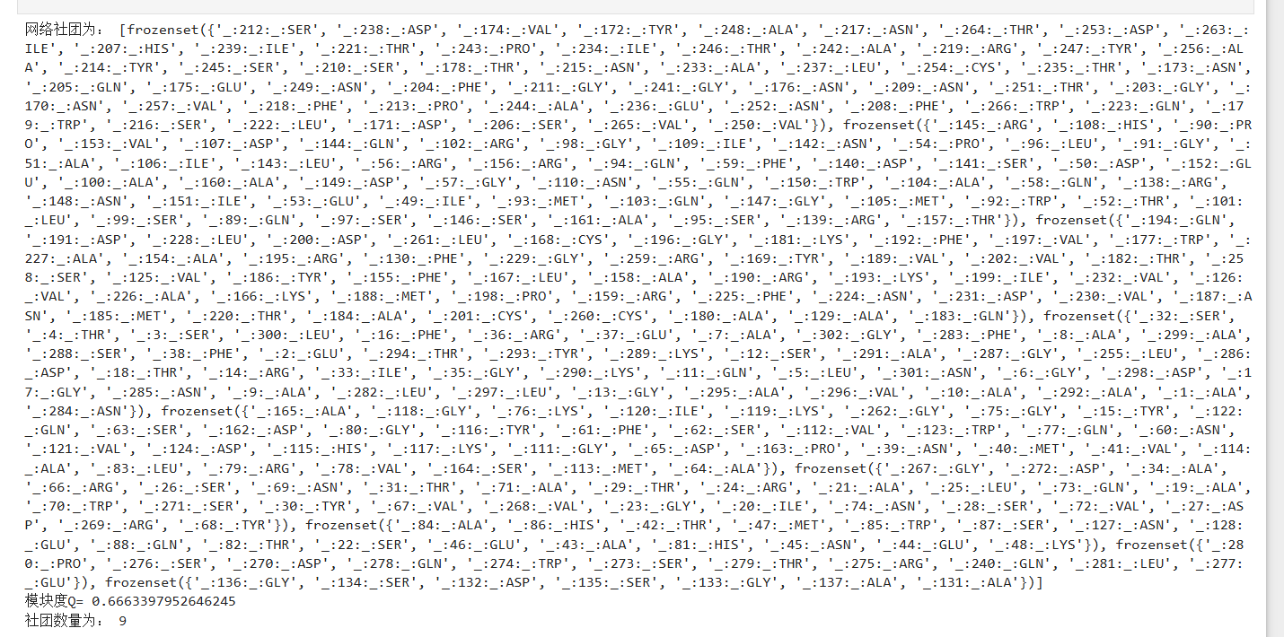
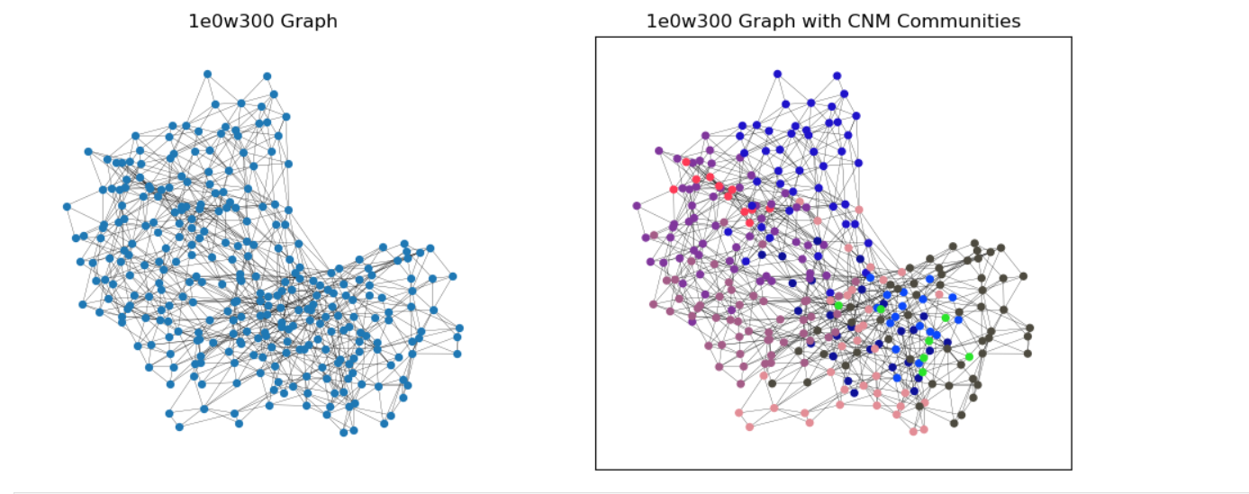
# Louvain 算法
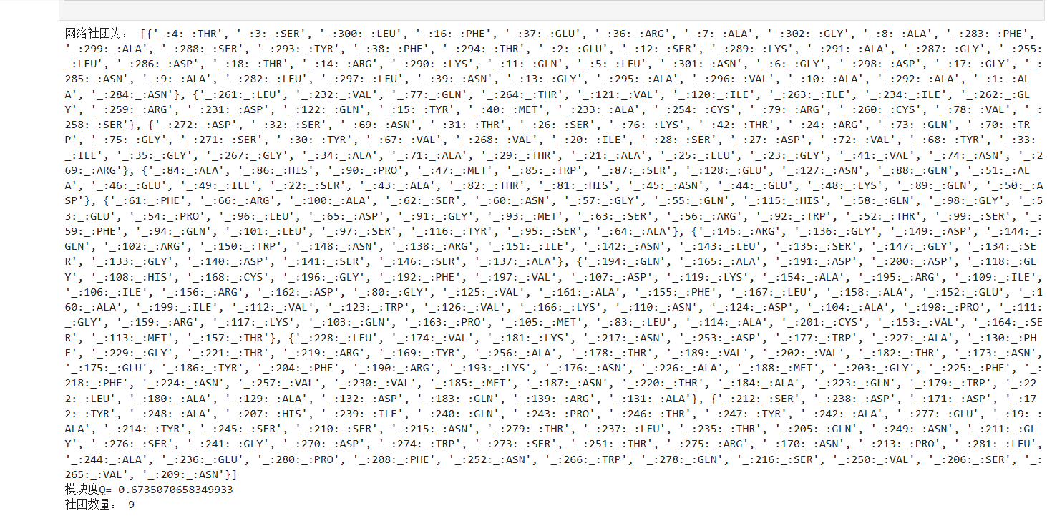
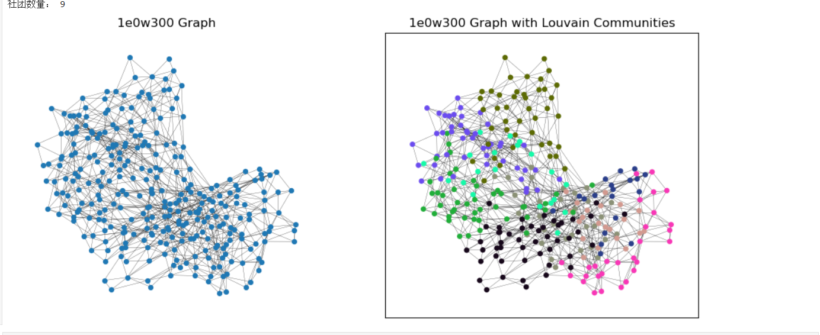
# 标签传播算法进行社团检测
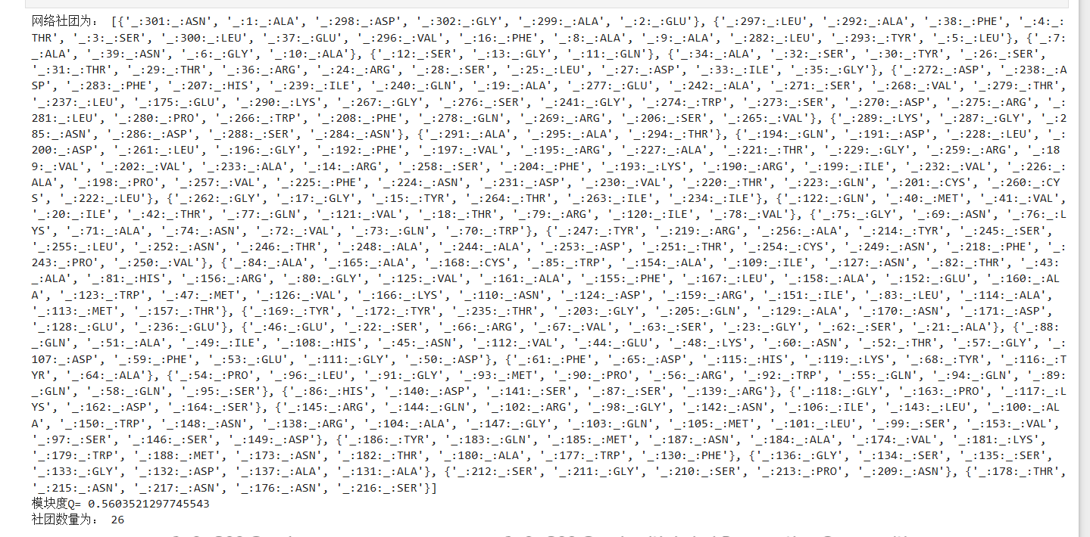
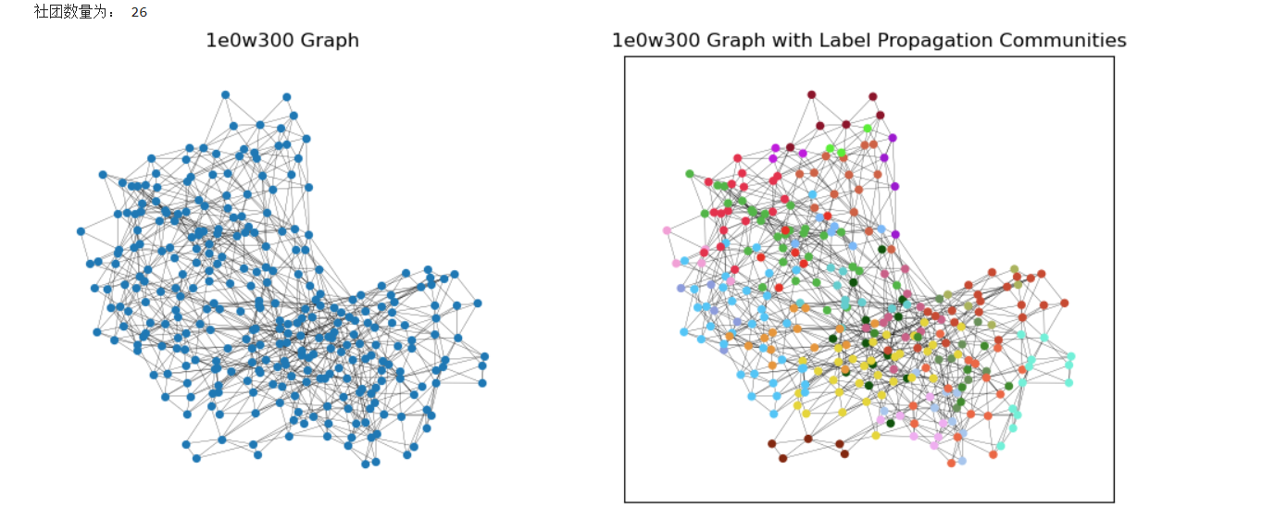

第二题：
